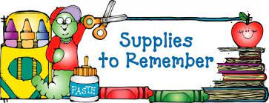

Fifth Grade

* 4 composition books
* pencils (No pencil sharpeners please)
* colored pencils
* dry erase markers
* 3 packs of loose leaf wide ruled paper
* index cards
* scissors
* cap erasers
* highlighters
* glue sticks
* 4 pronged folders
* 1 inch binder for ELA
* grid paper
* ink pens for ELA only

**Teacher Wish List**

scotch tape pencils

post It notes sandwich bags

pack of colored paper lysol spray

paperclips expo markers

Kleenex sticky notes

**\*\*Students may bring bottled water daily!\*\***